How to improve your Operational efficiency using ERPNext and work from anywhere for Sales Staff

ERPNext is a generic ERP software used by manufacturers, distributors and services companies. It includes modules like accounting, CRM, sales, purchasing, website, e-commerce, point of sale, manufacturing, warehouse, project management, inventory, and services.

Today it is very difficult for large cooperates to operate without an efficient IT system.
Automation of internal processes will result in efficiency and effectiveness and putting the organisation in a strategic position in the market.

In this article we are going to look at ERPNext’s CRM module and how it impacts the commercial department of an organisation

The ERPNext’s client relationship module is used to assist the sales organisation with the sales processes thus from the lead to all the way till an opportunity has been converted or lost. Below is the dashboard of the CRM Module:

fig.1

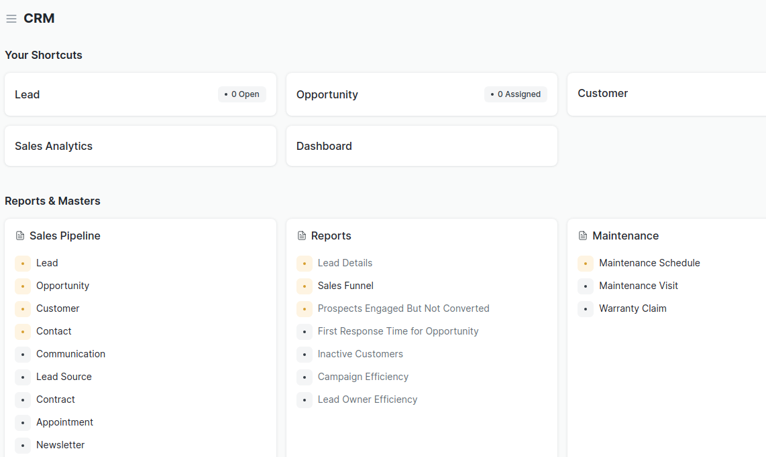

ERPNext is created in such a way that sales personnel log in all the leads and opportunity in the system for automated tracking,many of times companies lose out on lucrative deals as a result of no follow up or forgetting to follow up at all.

The advantages of using the system include:

- Shortening the time necessary to reach the recipient,
- Efficient and cost effective marketing campaigns can be run from this platform
- Customer service improvement
- Information Integration across functional departments
- Better relationships with customers increasing the customer retention
- Better protection of data privacy
- Easier follow through on customer database when an employee leaves the company

The design of the ERPnext’s CRM module was infused with the tools which allow departmental efficiency and dependencies with other departments within the organisations .Clearly showing dashboards and several useful reports required

- Email campaign

Email marketing helps you connect with your audience to promote your brand and increase sales. You can do a lot of things with emails, like sell products, share

- Lead details report

It has a comprehensive report on all the leads which have been entered in the system

- Sales funnel reports

The sale funnel report shows the managers to have an overview of sales opportunities at different stages in the sales cycle getting an idea of all the potential customers

- Prospects engaged but not converted

A report on the leads which did not convert,giving the opputunity to fine tune the sale process,engagement and product dev to reduce this number

- Inactive customers

A report of all inactive customer who have been inactive for a specific period,

- Campaign efficiency

This will be a report on the effectiveness of a campaign which was run via the system showing the effectiveness of the system

- Lead owner efficiency

This is an assessment of the quality of leads coming from different sales personnel which can assist checking the abilities of the team to close deals

- Record Maintanance Shedule for leased machines

Depending on the type of business,the CRM helps in making sure that sheduled tasks for customers are met on time

- Warranty claims

A record of warrant claims from customer,tracking and comments on the warrant request on a product

- Contract Management

This functionality allows management of contract with clients as they are attached in the system together with the related data this will assist in the event of a contractual breach we can always log into the system and retrieve the the document for reference purposes.

- Newsletter Distribution

At the end of the month of a financial quarter an auto generated newsletter can be sent to all the customers who have signed up to receive it or a certain group.

- Appointment scheduling

Over and above all the meeting appointment with clients is made via the CRM which allows easy tracking of productive time of the sales staff

